Instructions for Completing the Justice System Funding (Act 87) Schedules
Fiscal Years Ending on or after december 31, 2024
Local Government SERVICES

TABLE OF CONTENTS

Page

General Information 1
How to Use the Updated Schedules 3
- Agency Information Tab 4
- Agency Search Form 6
- Collecting/Disbursing Schedule 9
- Disbursement Detail 13
- Data Entry Form – Collecting/Disbursing Schedule 15
- Authority Search Form 17
- Receiving Schedule 19
- Data Entry Form – Receiving Schedule 21
Confirm: Close Schedule 22
Information Window 23
Error Window 24
Error Tab 25

Instructions
Act 87 of the 2020 Regular Legislative Session (R.S. 24:515.2) requires the Louisiana Legislative Auditor (LLA) and the Louisiana Supreme Court (LSC) to develop a uniform reporting format for local and state agencies that assess, collect, or receive revenue from pre- or post-adjudication costs, fines, and fees.
General Requirements
To meet the Act’s requirements, the LLA and LSC developed two reporting schedules (Schedules) that must be included in audit reports, review/attestation reports, and compilation reports.
The Schedules are classified as Supplementary Information, requiring an in-relation opinion for audit reports, and must be completed on the cash-basis. All amounts on the Schedules should be entered as positive numbers.
Each Schedule includes two six-month columns to allow the LLA to reconcile between collecting/disbursing and receiving agencies with different fiscal year ends. These columns should correspond to each six-month period of the agency's fiscal year activities.
It is important to note that Schedules are not required for Justices of the Peace or Constables, nor are they required if the agency has no amounts to report (i.e., blank Schedules are not required).
Description of Schedules
The two Schedules that have been devised are the Collecting/Disbursing Schedule and the Receiving Schedule.
- The Collecting/Disbursing Schedule must be completed by all agencies (e.g., sheriffs) engaged in the collection and/or disbursement of pre- or post-adjudication costs, fines, and fees associated with the justice system, including both criminal and civil matters, to other agencies. This includes amounts collected by an agency on behalf of itself.

- The Receiving Schedule must be completed by all agencies (e.g., courts, parishes, public defenders) that receive such fees/fines from another collecting/disbursing agency.

Schedule Changes
Significant changes have been made to the Schedules in order to address issues noted during the LLA’s review of data previously submitted. All agencies must use the updated Schedules starting with fiscal years ending on or after December 31, 2024 [Note: Agencies should use the Schedules dated February 2023 for fiscal years that end before this date.]
The key changes made to these Schedules are as follows:
- The Collecting/Disbursing Schedule and the Receiving Schedule have now been merged into one document.

- Agencies that distribute funds to other governmental or nonprofit entities must now specify the law that authorizes the disbursement, choosing from the approved list of state laws or inputting the relevant local ordinance. They must also record the specifics of these disbursements on the Disbursements to Other Governments & Nonprofits Form.

- When selecting agency names for transactions, users must use names from the built-in list of agency names, unless the funds are being disbursed to out-of-state agencies.

- The Schedules have been modified to better regulate their editing.

- The Schedules now include error checks to assist users in identifying and correcting data issues.

Note: The lists of state statutes and agency names may not be entirely complete/current. If you identify any issues with the information in these lists, please notify the LLA about this issue using the web form on the LLA website.

How to Use the Updated Schedules
- Save the Justice System Funding Schedule Excel file to your computer.
- Open the Justice System Funding Schedule spreadsheet.

Enable Content

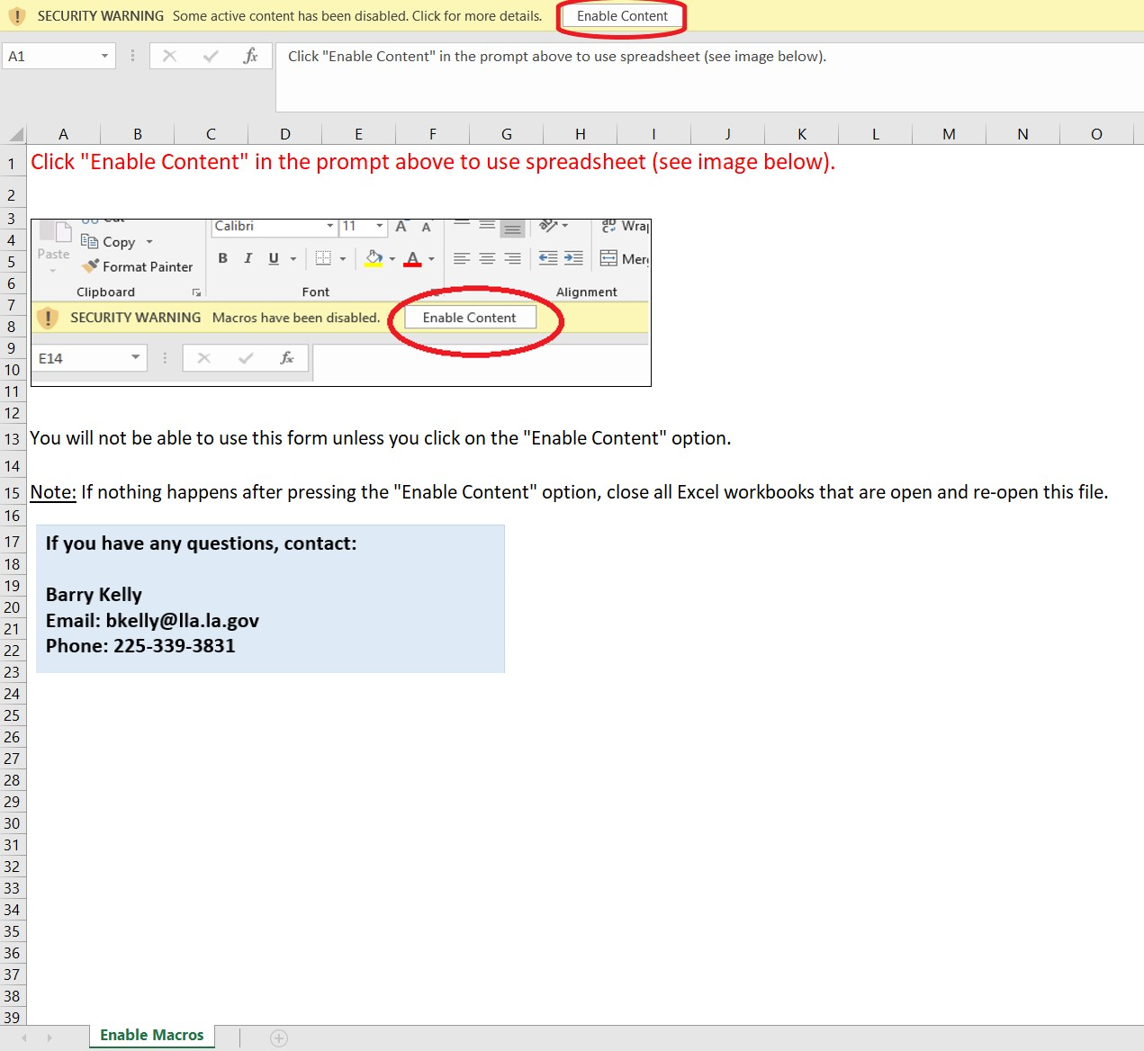

When you first open the schedule, you may see that the schedule prompts you to Enable Content. You must click on the Enable Content button at the top of the screen in order to use the schedule. This will allow the macros in the schedule to run.

Agency Information Tab
The Agency Information tab contains information about your agency. You must complete this form prior to entering data regarding collections/disbursements and money received.
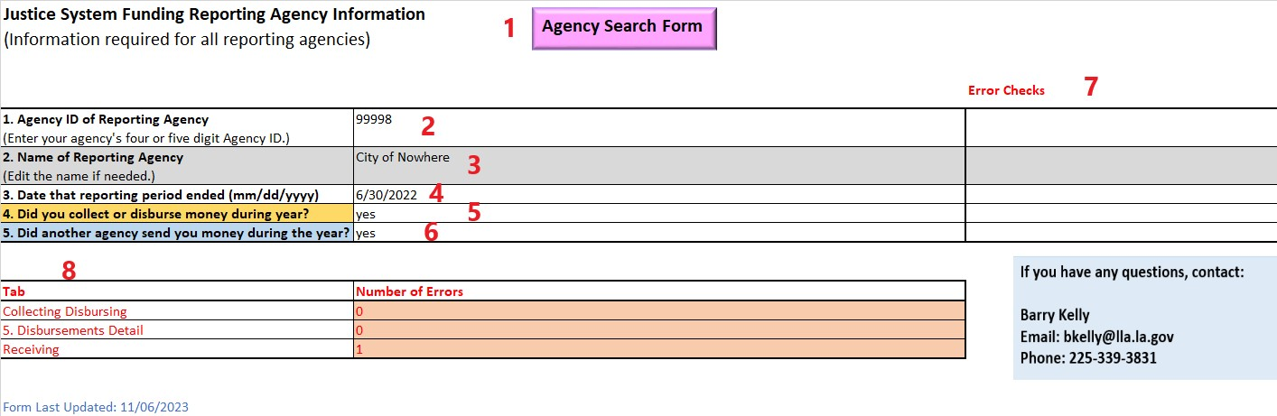

- Agency Search Form Button

- This button opens the Agency Search Form which allows you to search for your agency name as it appears in the approved agency list. This form allows you to identify your Agency ID. [See the Agency Search Form Button section below for more information on the Agency Search Form.]

- The use of this form is optional.

- Agency ID of Reporting Agency

- The Agency ID is the 4- or 5-digit number assigned to your agency by the LLA.

- When you type in your Agency ID, the Name of Reporting Agency (see #3 below) will be completed automatically.

- This information is required.

- Name of Reporting Agency

- This is the name of your agency as it appears on the approved agency list.

- You can edit the name, if necessary.

- This information is required.

- Date that Reporting Period Ended (MM/DD/YYYY)

- This is the date that the fiscal year you are reporting on ended. For example, 6/30/2024 indicates that you are reporting on the fiscal year 7/1/2023 through 6/30/2024.

- This information is required.

- Did You Collect or Disburse Money During Year?

- Enter “Yes” if your agency did collect or disburse money during the year.

- Enter “No” if your agency did not collect or disburse money during the year.

- This information is required.

- Did Another Agency Send You Money During the Year?

- Enter “Yes” if your agency received money from another agency during the year.

- Enter “No” if your agency did not receive money from another agency during the year.

- This information is required.

- Error Checks Column

- This column is used to identify and flag any errors in the data entered into the Agency Information tab.

- All errors that appear in this window must be corrected prior to completing other Schedules.

- Number of Errors Section

- This section counts the number of errors found on all Schedules.

Note: Once you have completed the Agency Information tab, the other Schedules in the spreadsheet will be unlocked and available for use.
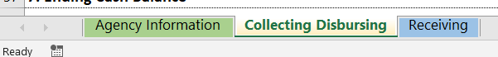

Agency Search Form Button
This button opens the Agency Search Form (see next image below), which allows you to search for agency names as they appear in the approved agency list. This form may be used to find your own agency (when completing the Agency Information tab) or other agencies (when completing other tabs).

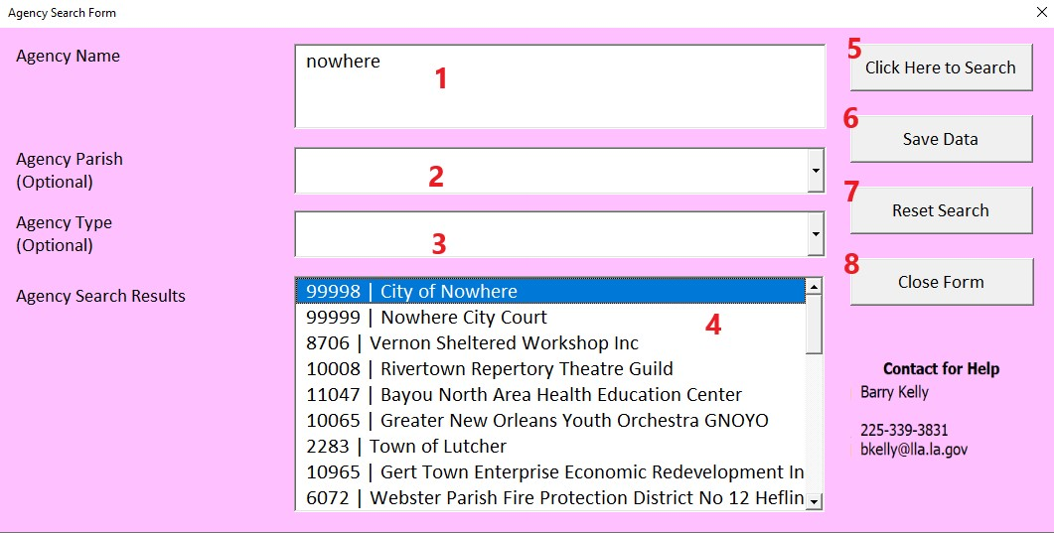

- Agency Name

- This box allows you to search for an agency using the agency’s full name or a partial name.

- This information is optional.

- Agency Parish

- This drop-down menu allows you to select or type a parish name in order to search for an agency by parish.

- This information is optional.

- Agency Type

- This drop-down menu allows you to select or type an agency type (e.g. sheriff) in order to search for an agency by agency type.

- This information is optional.

- Agency Search Results

- After clicking on the “Click Here to Search” button (see #5 below), this section will populate with agency search results.

- Select the desired agency from the list.

- This information is optional.

- Click Here to Search Button

- Click this button to search for agencies using the information you entered #1 through #3 above.

- Search results will appear in the Agency Search Results (#4 above).

- Save Data Button

- Click this button after selecting the appropriate agency from the Agency Search Results (#4 above). This button saves your selected agency from the Agency Search Results to the worksheet automatically.

- If you are using this form in other tabs, this form will automatically complete the agency name in the Data Entry Form (see information about this form later in this document).

- Reset Search Button

- Click this button to clear the search criteria you entered in #1 through #3.

- Close Form Button

- Click this button to close the Agency Search Form.

Collecting/Disbursing Schedule

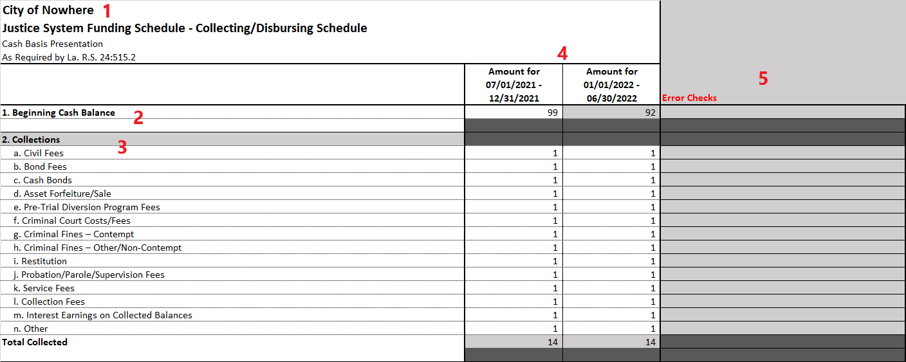
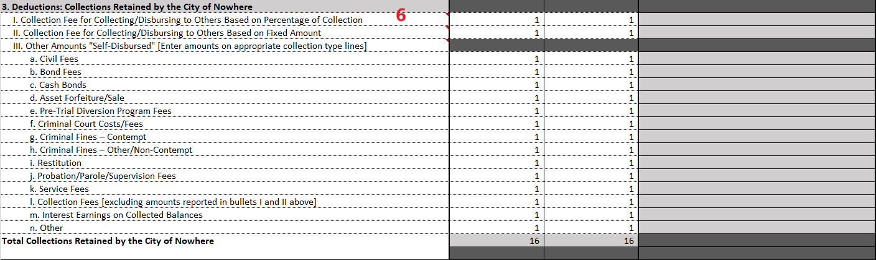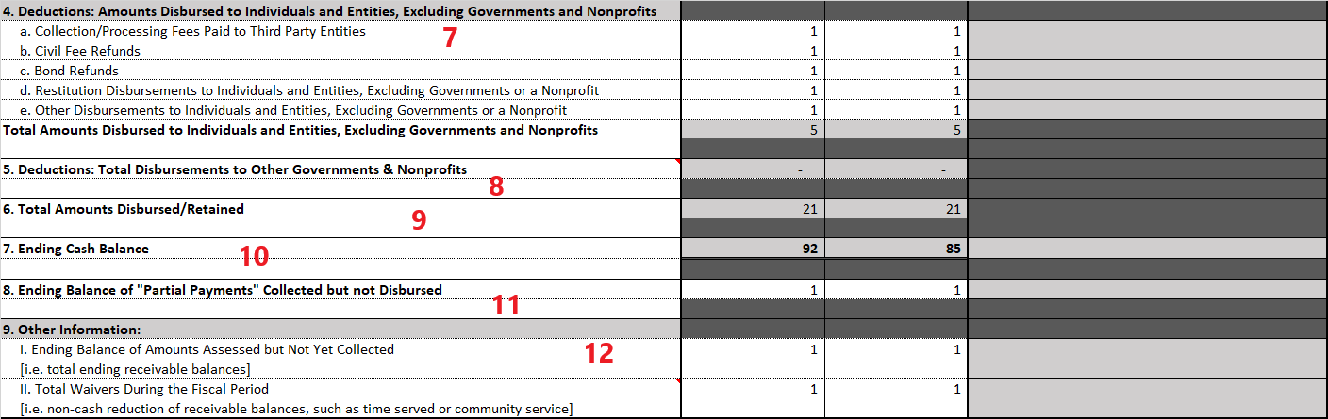

- Agency Name

- Your agency’s name, as entered on the Agency Information tab, will appear here.

- This section will be completed automatically.

- Beginning Cash Balance

- This is the amount of cash carried over from the prior year.

The beginning balance for the second 6-month period will automatically be calculated using the ending balance for the first 6-month period.

- This information is required.

- Collections

- This section contains the amounts that your agency collected during the fiscal year, categorized by collection type.

- This information is required.

- 1st and 2nd Halves of Fiscal Year Columns

- The first column represents the first 6-month period and the second column represents the second 6-month period of the fiscal year.

- All cells, except those highlighted in grey, must be completed. Cells that may contain errors are highlighted automatically.

- Error Checks Column

- This column is used to identify any errors in the data entered.

- You must correct all errors that appear in this column prior to completing #8 below or submitting the schedule to the LLA.

- Collections Retained by Your Agency

- This section contains the amounts that your agency retained for itself during the fiscal year.
- For more detailed instructions, hover over the cells with a red triangle in the upper-right corner of a cell.

- This information is required.

- Amounts Disbursed to Individuals and Agencies, Excluding Governments and Nonprofits

- This section contains the amounts that your agency disbursed to individuals and other agencies (other than governments and nonprofits).

- This information is required.

- Total Disbursements to Other Governments & Nonprofits

- This section contains the amounts that your agency disbursed to other governments and nonprofits. These amounts will be automatically completed based on the information you enter on the “5. Disbursements Details” tab.

Note: The “5. Disbursements Details” tab will only become available when all errors in the error column have been resolved.

- For more detailed instructions, hover over the cell with a red triangle in the upper-right corner of a cell.

- Total Amounts Disbursed/Retained

- This section shows the total amount disbursed and retained.

- This is automatically calculated by the schedule.

- Ending Cash Balance

- This section is the ending cash balance for each 6-month period.

- This is automatically calculated by the schedule.

- Ending Balance of "Partial Payments" Collected but not Disbursed

- This section is for partial payments that were collected by your agency that will not be disbursed until fully collected.

- This information is required.

- Other Information

  - Ending Balance of Total Amounts Assessed but not yet Collected

    - This section is the amount of fees, fines, etc. that were previously assessed and are still owed, but not yet collected.

    - This information is required.

  - Total Waivers During the Fiscal Period

- This section is the total waivers granted against balances owed during the period (i.e. noncash reductions to balances owed). For example, waivers could include time served or community service that reduce the required amount to be paid.

- For more detailed instructions, hover over the cell with a red triangle in the upper-right corner of a cell.

- This information is required.

5. Disbursements Details Schedule
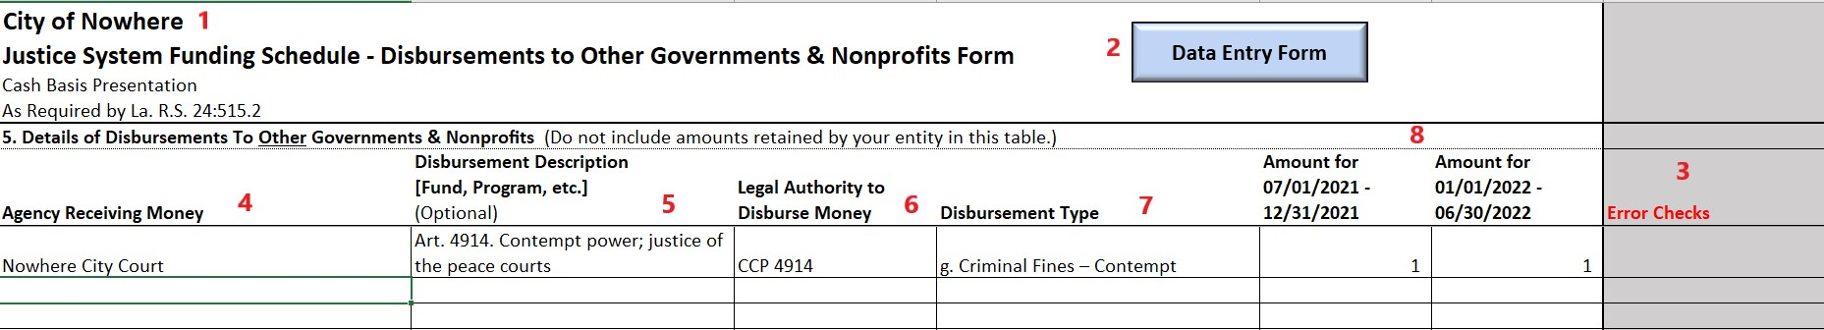

- Agency Name

- Your agency’s name, as entered on the Agency Information tab, will appear here.

- This section will be completed automatically.

- Data Entry Form Button

- Click this button to open the Data Entry Form (see Data Entry Form section below for more information). This form allows for easier data entry into this schedule.

- The use of this form is optional.

- Error Checks Column

- This column is used to identify any errors in the data entered.

- You must correct all errors that appear in this column prior to submitting the schedule to the LLA.

- Agency Receiving Money Column

- This column contains the names of governmental and nonprofit agencies to whom your agency disbursed money.

- Names appearing in this column must be spelled exactly as they appear in the approved agency list. It is recommended that you use the Data Entry Form to complete this section.

- For out of state agencies, you must type “Out of State:” and then the agency name. For example, for Dallas City Court, you would type “Out of State: Dallas City Court”.

- This information is required.

- Disbursement Description Column

- This column contains the descriptions of the disbursements your agency made.

- When using the Data Entry Form, the form will automatically complete the disbursement description. However, you may edit these descriptions as you see fit.

- This information is optional.

- Legal Authority to Disburse Money Column

- This column contains the laws that authorize your agency to collect and disburse money. It is recommended that you use the Data Entry Form to complete this section.

- For local ordinances, you must type “Local Ordinance:” and then the ordinance information. For example, for City Ordinance 123, you would type “Local Ordinance: City Ordinance 123”.

- This information is required.

- Disbursement Type Column

- This column contains the collection type (e.g. “a. Civil Fees”) of the money that your agency disbursed.

- This information is required.

- 1st and 2nd Halves of Fiscal Year Columns

- The first column represents the amounts for the first 6-month period and the second column represents the amounts for the second 6-month period of the fiscal year.

- This information is required.

Data Entry Form – Collecting/Disbursing Schedule
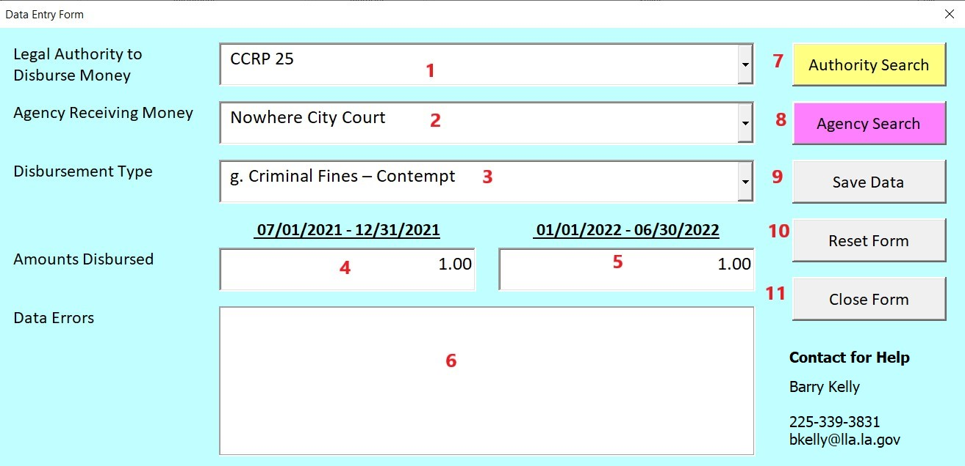

- Legal Authority to Disburse Money

- This drop-down menu allows you to select or type an appropriate state law. You will only see the laws that the LLA has determined your agency is associated with.

- For a local ordinance type in the name of the ordinance (e.g. “City Ordinance 123”). The form will automatically add “Local Ordinance:” in front of the name you entered and an information window will appear stating that the schedule considers this legal citation to be a city ordinance.

- This information is required.

- Agency Receiving Money

- This drop-down menu allows you to select or type an appropriate agency from the approved agency list. You will only see the agencies that are associated with the laws to which your agency is associated with.

- This information is required.
- Disbursement Type

- This drop-down menu allows you to select or type an appropriate collection/disbursement type (e.g. “a. Civil Fees”) for the distribution.

- This information is required.

- 1st Half of Year Box

- This box allows you to type the amount of the distribution for the 1st half of the year.

- This information is required.

- 2nd Half of Year Box

- This box allows you to type the amount of the distribution for the 2nd half of the year.

- This information is required.

- Data Errors Box

- This box is used to identify any errors in the data you entered.

- Authority Search

- Click this button to access the Authority Search Form if you need help finding the appropriate state law. See Authority Search Form section below for more information.

- Use of this button is optional.

- Agency Search

- Click this button to access the Agency Search Form if you need help finding the appropriate agency. See Agency Search Form section earlier in this document for more information.

- Use of this button is optional.

- Save Data

- Click this button when you are ready to post the information in the form into the schedule.

- Use of this button is required.

- Reset Form

- Click this button if you need to clear the information out of all the boxes in the form.

- Close Form

- Click this button to close the form.

Authority Search Form

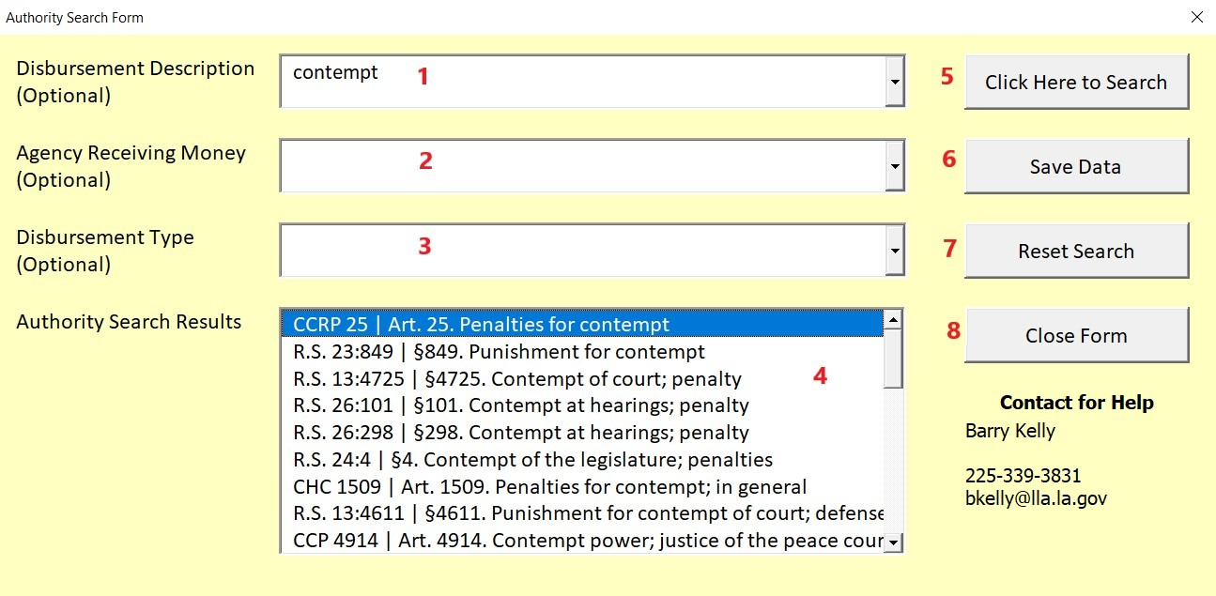

- Disbursement Description

- Type or select a legal description to search for legal citations by description.

- This use of this box is optional.

- Agency Receiving Money

- Type or select an agency name to search for legal citations by agency name.

- The use of this box is optional.

- Disbursement Type

- Type or select a collection/disbursement type (e.g. “a. Civil Fees”) to search for legal citations by type.

- The use of this box is optional.

- Authority Search Results

- After clicking the “Click Here to Search” button (See #5 below) this section will populate with authority search results.

- Select the authority from the list.

- Click Here to Search

- Click this button to search for legal citations based on the information entered in #1 through #3 above.

- Search results will appear in the Authority Search Results (see #4 above).

- Save Data

- Click this button after selecting an option from the Authority Search Results (see #4 above). This button will populate the Data Entry Form with the legal authority selected.

- Reset Form

- Click this button to reset the search criteria for the form.

- Close Form

- Click this button to close the form.

Receiving Schedule

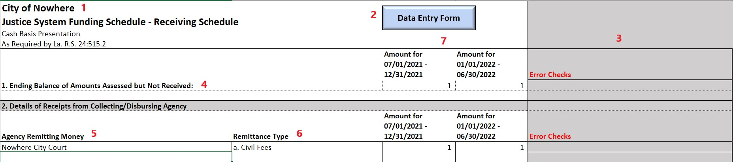

- Agency Name

- Your agency’s name, as entered on the Agency Information tab, will appear here.

- This section will be completed automatically.

- Data Entry Form Button

- Click this button to open the Data Entry Form (see Data Entry Form section below for more information). This form allows for easier data entry into this schedule.

- The use of this form is optional.

- Error Checks Column

- This column is used to identify any errors in the data entered.

- You must correct all errors that appear in this column prior to submitting the schedule to the LLA.

- Ending Balance of Amounts Assessed but Not Received

- This section is the total amount that was assessed but not received (i.e. receivable balances).

- This information is required.

- Agency Remitting Money

- This column contains the names of governmental and nonprofit agencies who remitted money to your agency.

- Names appearing in this column must be spelled exactly as they appear in the approved agency list. It is recommended that you use the Data Entry Form to complete this section.

- For out of state agencies, you must type “Out of State:” and then the agency name. For example, for Dallas City Court, you would type “Out of State: Dallas City Court”.

- This information is required.

- Remittance Type

- This drop-down menu allows you to select or type an appropriate remittance type (e.g. “a. Civil Fees”) for the money received.

- This information is required.

- 1st and 2nd Halves of Fiscal Year Columns

- The first column represents the amounts for the first 6-month period and the second column represents the amounts for the second 6-month period of the fiscal year.

- This information is required.

Data Entry Form – Receiving Schedule

The instructions for the Data Entry Form was covered earlier in this document. The difference when using the Data Entry Form on the Receiving Schedule is that the legal citation/authority box and search button is not available, since this information is not required on the Receiving Schedule.

Confirm: Close Schedule

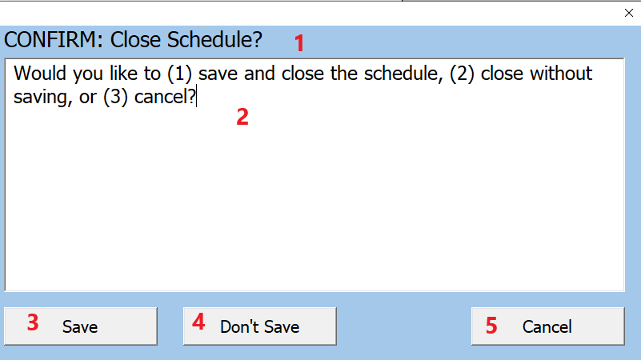

When closing the schedule, you will be given the prompt in the screenshot above.

- Window Title

- This is the title of the window.

- Window Description

- This explains your options related to closing the schedule.

- Save

  - Click this button if you want to save and close the schedule.

- Don’t Save

- Click this button if you want to close the schedule without saving.

- Cancel

- Click this button if you don’t want to close the schedule.

Information Window
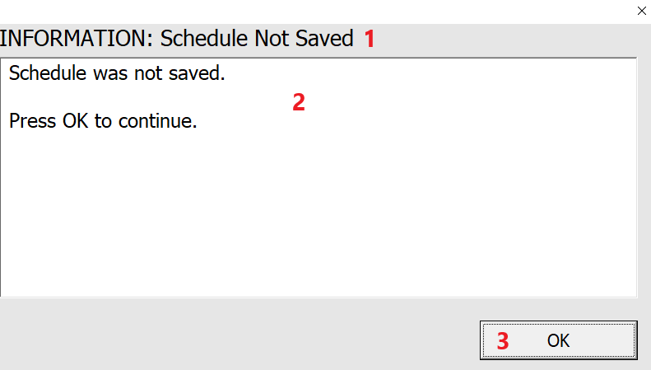

While using the form, the schedule may display important information in popup windows like the one in the screenshot above.

- Window Title

- This is the title of the window.

- Window Description

- This explains the issue that caused the window to be displayed.

- OK Button

- Click this button to close the window.

Error Window

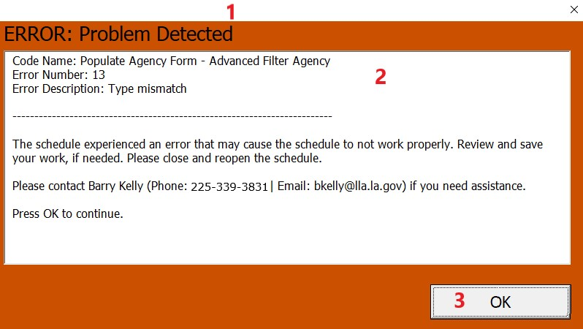

While using the form, you may come across an error while using the form. The schedule will display information about this error in popup windows like the one in the screenshot above.

- Window Title

- This is the title of the window.

- Window Description

- This explains the error that caused the window to be displayed.

- OK Button

- Click this button to close the window.

Error Tab

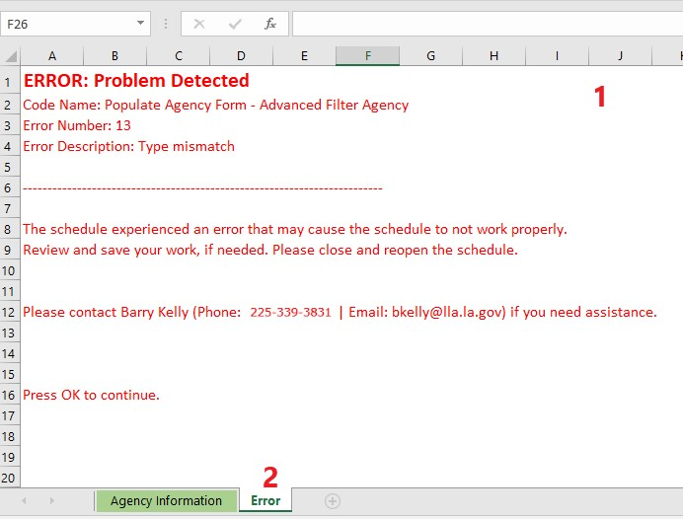

When an error occurs with the schedule, the spreadsheet will select the Error worksheet, which will explain the error that caused the issue. This tab will be closed when you close the workbook or select another tab in the schedule.

